For iPad
You will be sent an invite through your email address. Open email invite and click “Yes” for attendance
Then click on “Join Microsoft Teams Meeting”
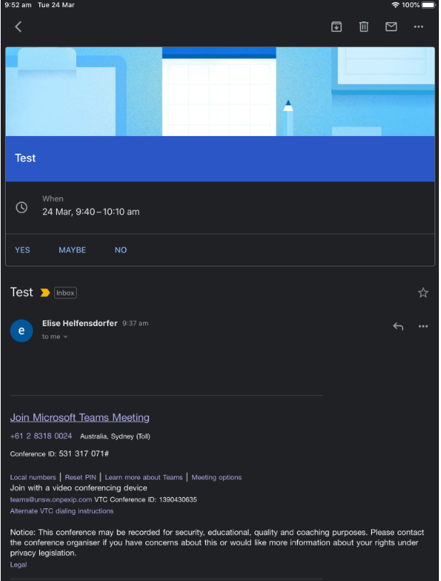

The below screen will appear and if you don’t already have the app you will need to download it on the app store (it’s a free app)
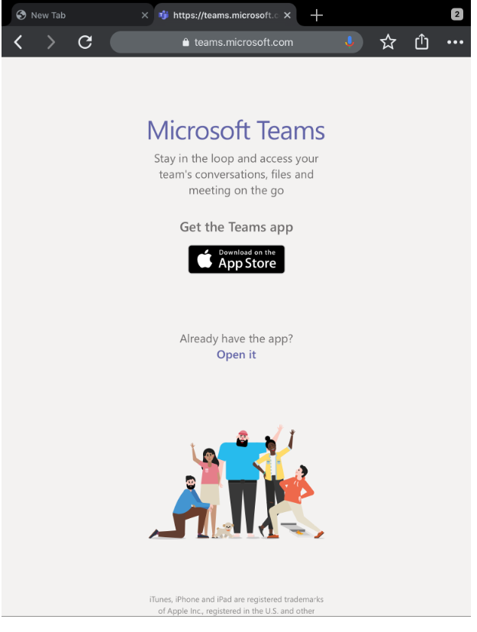

Click on “GET”
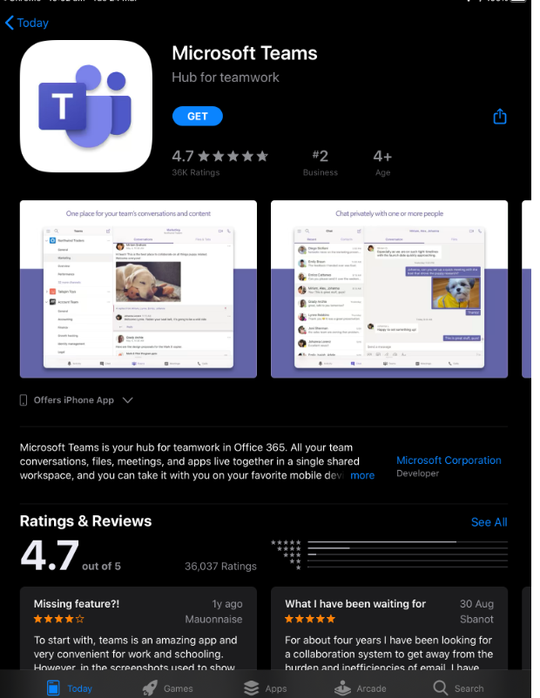

After it has downloaded you will be able to click on “OPEN”

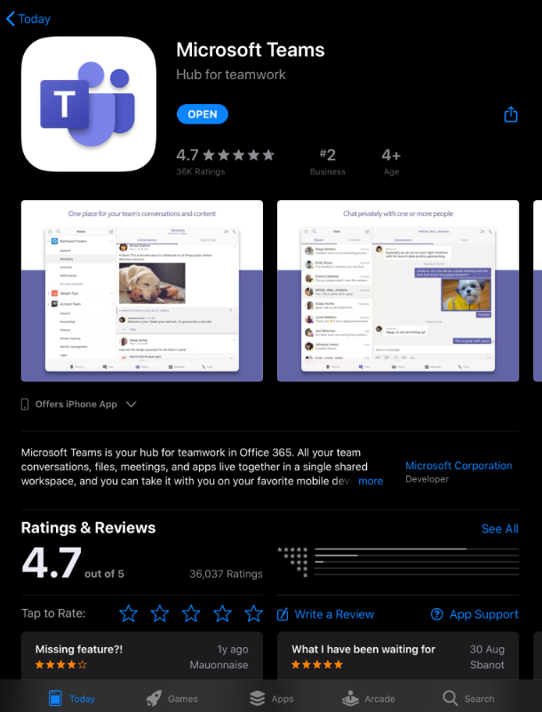

If a meeting has been scheduled and you have clicked attending then the below screen should appear. You can then click “Join as guest”

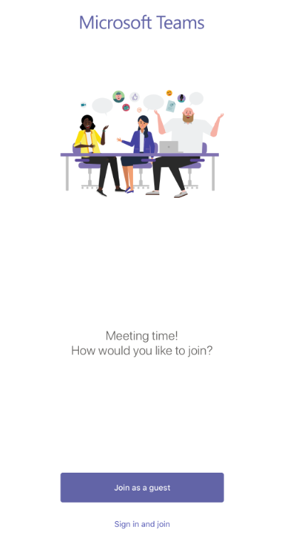

If your microphone is not already on this box will appear. Click “OK” to allow access to Microphone so you will be able to communicate throughout the consultation
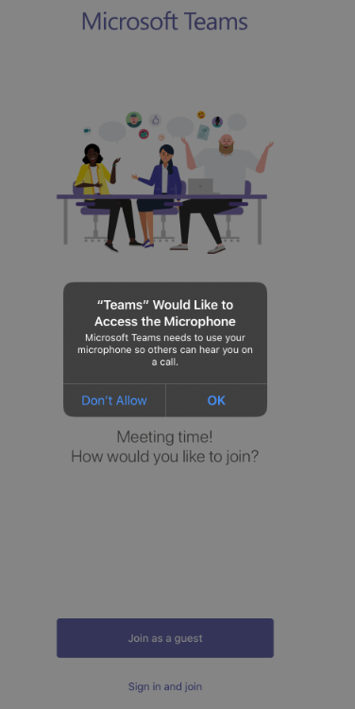

You are then able to join as a guest by putting in your name and then selecting “Join Meeting”
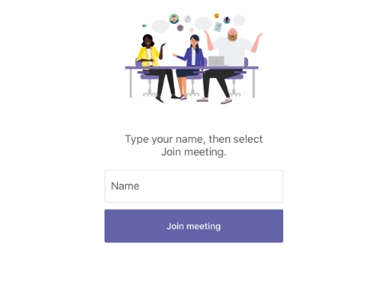

The below screen should appear with your name there. Once again ensure your microphone is on and if you have video facilities turn on video (if not already on) to enhance your consultation. Please note the consultation is still able to occur if there are only microphone facilities.
You will need to wait for your Exercise Physiologist to allow you access to join the meeting.
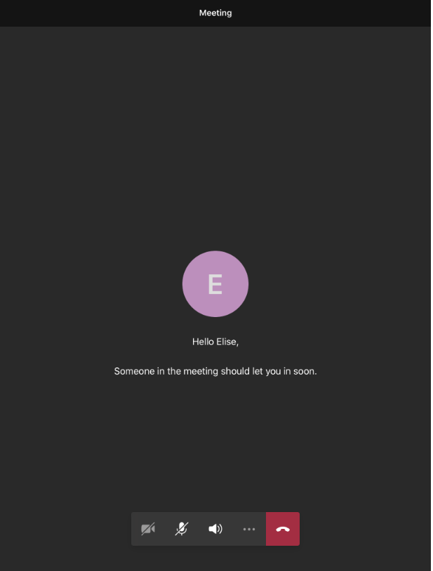

Enjoy your session!

